

**National University of Modern Languages**

**PROGRAMMING FUNDAMENTALS**

**Spring 2024**

**LAB 2**

**NAME: IFFAT**

**ROLL NUMBER: 3357**

**PROGRAM: BSCS (1ST SEMESTER)**

**SECTION: A**

**SUBMITTED TO: Ms. Shumaila Qayyum**

1.Write two program s finding out average of three numbers.

a. By initializing a value

Code:

#include<iostream>

using namespace std;

int main()

{

int a=5,b=8,c=13;

float avg;

int sum = a+b+c;

avg=sum/3;

cout<<" Average of numbers="<<avg;

return 0;

}

**OUTPUT:**

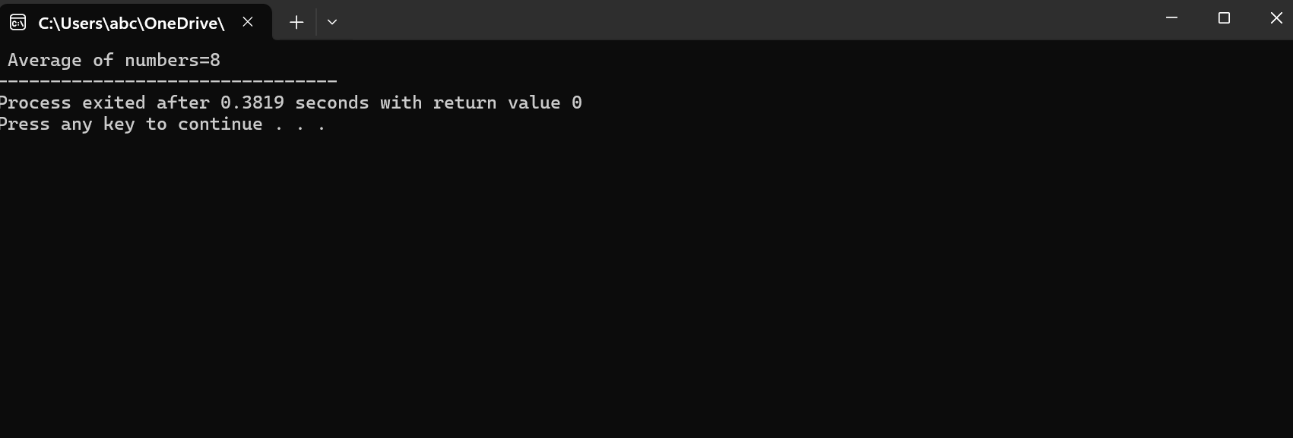

b. By using input from user

**Code:**

#include<iostream>

using namespace std;

int main()

{

int a,b,c;

float avg;

cout<<" Enter three numbers:";

cin>>a>>b>>c;

int sum = a+b+c;

avg=sum/3;

cout<<" Average of numbers="<<avg;

return 0;

}

**OUTPUT:**

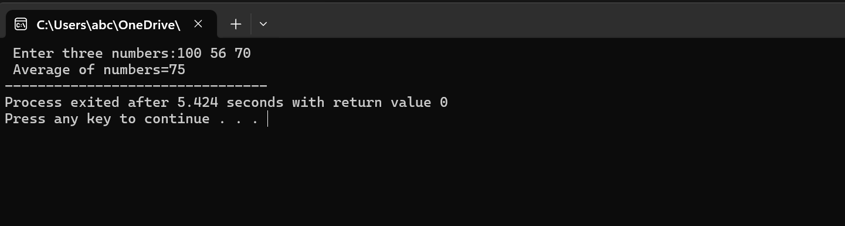

2.Draw any character using

a. Using any special symbol

b. Using escape sequence

**Code:**

#include<iostream>

using namespace std;

int main()

{

cout<<"+++++\n";

cout<<" +\n";

cout<<" +\n";

cout<<" +\n";

cout<<"+++++\n";

return 0;

}

**OUTPUT:**

